Enhancement of nursing program to students
Student’s Name:
Institution:

Enhancement of the nursing program to students
With the new interim formation in the department of nursing, rapid growth in the implementation and use of electronic in the medical field has been fostered with clarity (Oh, & Lim, 2019). There is an increase in how we persuade in defining a nurse and other members as the role model in building and developing the nursing community as room for engaging in patient consultancy. Visiting the department of nursing in the school of medicine is the aspect that it entails what is being seen as the department that encourages everyone to pursue their career in the nursing industry.
From the visit put into the present day, the first gathering is to look into the way the department arrange their working. What composition of the workplace that the great medical nurses are welcome and given direction about the various departments. Putting into question on matters with sanity, the first person that pays attention to listen to my interview was from the lab technician (Oh, & Lim, 2019). The drive of the department has put an array of equipping the hospital with a full set of medical ranging from the lab report, patient attendance list of the workers union. In the present position, the question goes directly to the registrar of inpatients and outpatients on how they always manage their roll call to avoid neglecting the operation in the department.
Reflecting on the daily program created for the nursing students, it is out of great concern that the remedy of student visits. This is a welcoming key that no one opposes any student to be incorporated in any nursing hospital. The brief communication has brought to the head of the department is to plan how the nursing community works well (Oh, & Lim, 2019). However, it will gather every nurse who has skill and understanding of attending to the sick person. The first impression that is usually received when taking any interrogation about the nursing department is the treatment of workers. The other thing is the way of obtaining any guest person in the department. It might be hard to learn about the department in the nursing sector. The first impression you are being received means a lot; second is the person who attends to listen to what you need to give to them.
Along with the provision of optimal care, nurses are also responsible for interpreting and giving accurate documentation with a large amount of information. The information that nursing performs is to interact with the management teams in communication and support the health of the people across the globe. However, It is hard to know a place but making an impromptu in the nursing sector in various parts of the hospital. This will definitely enable students to feel that they have the opportunity to give their dedication in managing to be given a position in such a great department in the nursing sector.
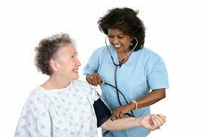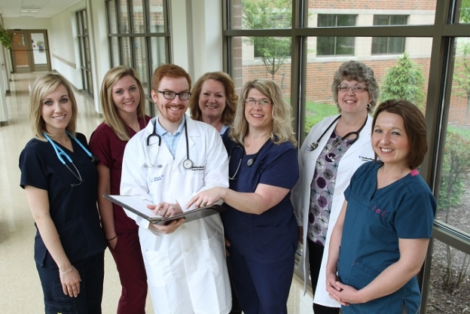

Reference
Oh, S. E., & Lim, J. Y. (2019). Developing and Evaluating a Camp-style Leadership Enhancement Program for Nursing Students. Journal of Korean Academy of Nursing Administration, 25(1), 52.

